# CS 255 System Design Document

## UML Diagrams

### UML Use Case Diagram

### UML Activity Diagrams

### UML Sequence Diagram

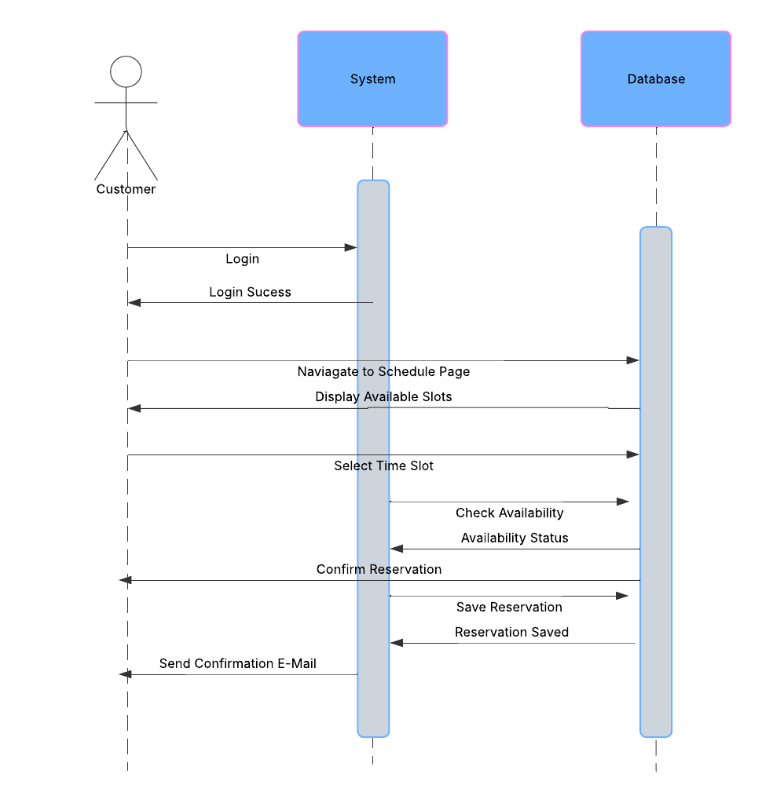

### UML Class Diagram

## Technical Requirements

The DriverPass system requires a robust technical infrastructure to support its functionality. The system must be hosted on a cloud-based platform to ensure scalability, reliability, and accessibility from any device with an internet connection. The back end will rely on a relational database management system such as MySQL or PostgreSQL to store and manage user data, reservations, lessons, and test results. The front end will be developed as a responsive web application compatible with major operating systems including Windows, macOS, and Unix-based systems. Development tools such as integrated development environments IDEs, version control systems like Git, and frameworks for web development will be essential. Security measures including HTTPS encryption, two-factor authentication, and automated backups must be implemented to protect sensitive data. Additionally, the system will require integration with third-party services for email notifications and real-time updates from the DMV. The infrastructure must support high concurrent user loads during peak times and provide regular updates to ensure compliance with evolving DMV regulations.